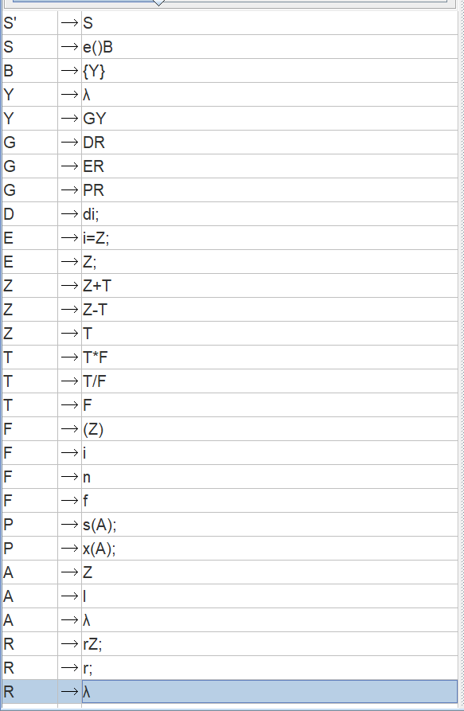

**NON-TERMINALS**

S: start symbol

B: block of code

Y: generates desired frequency of **group of code**

G : group of code,

D : declaration.

E : equations (grammar from E to F)

P : print.

A : argument of print statement.

R : generates **Return statements**.

**TERMINALS**

e : exe

d : datatype

i : identifier

n : integer number.

f : float number.

s : show (print function in our grammar)

x : showLine ( same as above)

r : means **reply (**that means **return)**